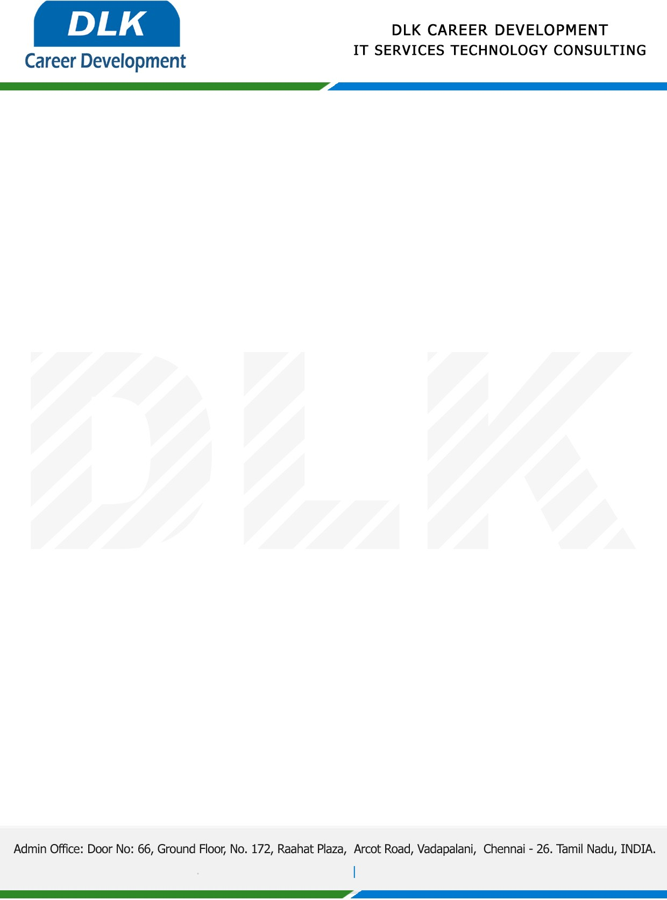

**Date: 05/ May /2023**

**SUB: PROJECT COMPLETION CERTIFICATE**

This is to certify that **MR JAGIR HUSSAIN N (REG NO: 832100038) MSC-Computer Science,** final year student **Pachaiyappa’s College for Men, Kanchipuram** has Successfully Completed the Project Work under the domain of “**Java”** in our organization during the Period **(December 2022** to **April 2023).**

**Topic:** Secure Content-Based Image Retrieval in the Cloud with Key Confidentiality.

We appreciate your interest in **DLK CAREER DEVELOPMENT**

**“Best Wishes for Your Future Endeavors “**

For **DLK CAREER DEVELOPMENT**

**HR Manager**

**VELMURUGAN J**